Graph Navigation ItemType Viewer

## Overview

This package contains a Graph View Definition that visually displays the configuration of any ItemType

Once installed, an administrator can display a graph view from any ItemType to see all of the standard configured templates in a single image. The example screenshot below shows the configuration for the ItemType ECO.

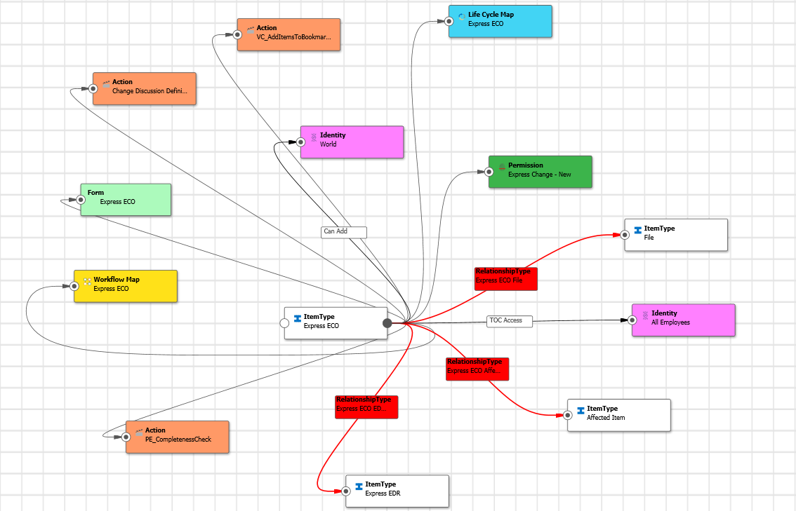

## Prerequisites

Aras Innovator 11 SP15 (or above).

## Installation

1. Unzip the GraphNavigationItemTypeViewer.zip file to a local directory.

2. Use the Package Import Utility to add the graph navigation definition to any 11 SP15 database. Note that you MUST be the root user to successfully complete the import.

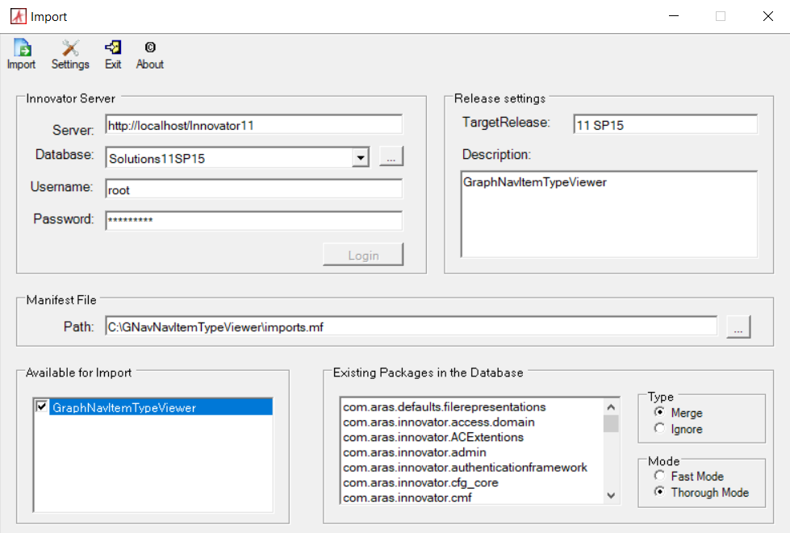

3. To try the viewer, login to Innovator as an administrator. Select any ItemType from the search grid and choose Show Graph from the context menu (right click).

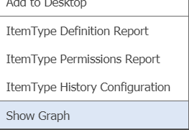

4. Select the ItemType_Viewer from the dropdown list to display the custom viewer. The starting ItemType node will be displayed. Click the node connector button to display the ItemType configuration:

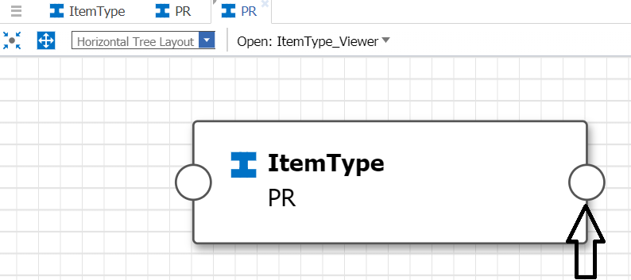

Use the Mouse wheel to zoom in and out and choose the various graph view layouts to show the results in different ways.

7. You can also right click on the starting node connector button to filter the output:

